شرح پروژه:

برنامهای بنویسید که مقدار *ای* را برای اینکه دو تابع زیر بیشترین شباهت را به هم داشته باشند، پیدا کن.

f(t) = 1/sqrt(1+t**2) , g(t) = e**-(a*t**2)

از 5 تا 0

در بازه ی 0 تا 0.2 با قدم های 0.001 آی را متغییر در نظر می گیریم و برای هر *ای* شباهت زاویه ای را روی بازه ی 0 تا 5 با قدم های 0.001 بدست آورده که به شرح زیر می باشد.

مقادیز شباهت زاویه ای:

0.48976879164547793_0.4867029086604084_0.4836755260754632_0.4806864798256852

0.47482270022701095_0.47194759980288814_0.4691101021529031_0.4663100060346906

0.46354710363835677_0.46082118086472224_0.45813201759868233_0.45547938797744275

0.45286306065376025_0.45028279905394586_0.44773836163064135_0.4452295021104256

0.44275596973605436_0.44031750950342924_0.43791386239331087_0.43554476559766003

0.433209952740794_0.43090915409516195_0.4286420967919193_0.4264085050263371

0.4242081002579509_0.4220406014055856_0.41990572503737167_0.4178031855555973

0.4157326953767073_0.413693965106254_0.41168670370909105_0.4097106186746969

0.4077654161778342_0.40585080123442996_0.4039664778530847_0.4021121491817652

0.40028751765036136_0.39849228510867235_0.396726152960178_0.3949888222916167

0.39327999399832847_0.391599368905722_0.3899466478865824_0.38832153197455666

0.38672372247384645_0.3851529210651214_0.38360882990764744_0.3820911517380825

0.38059958996551013_0.37913384876318046_0.3776936331567598_0.3762786491094292

0.3748886036036054_0.37352320471963163_0.3721821617113261_0.3708651850785317

0.36957198663676727_0.36830227958386286_0.3670557785639643_0.3658321997287214

0.3646312607957265_0.3634526811044611_0.36229618166958394_0.361161485231815

0.3600483163062861_0.35895640122870964_0.35788546819889655_0.3568352473223987

0.3558054706497052_0.3547958722133413_0.35380618806297387_0.35283615629832826

0.351885517100275_0.35095401275982535_0.35004138770533555_0.3491473885279748

0.3482717640051458_0.3474142651224638_0.34657464509375185_0.3457526593797458

0.34494806570491787_0.34416062407277703_0.3433900967798416_0.3426362484279726

0.3418988459354091_0.34117765854631366_0.34047245783903335_0.3397830177331429

0.3391091144950566_0.33845052674262155_0.33780703544831603_0.33717842394159486

0.33656447790982275_0.33596498539837605_0.3353797368095341_0.3348085249005658

0.3342511447806429_0.3337073939070843_0.3331770720804362_0.3326599814388937

0.33215592645179803_0.33166471391239133_0.3311861529297392_0.3307200549199822

0.3302662335968888_0.3298245049616385_0.3293946872921386_0.32897660113146165

0.3285700692759909_0.3281749167627297_0.32779097085625725_0.3274180610351829

0.32705601897789177_0.32670467854804247_0.32636387577964754_0.3260334488615298

0.325713238121571_0.3254030860105219_0.32510283708547716_0.32481233799304665

0.32453143745212226_0.32425998623649205_0.3239978371571312_0.3237448450441395

0.32350086672869405_0.3232657610244924_0.3230393887093225_0.32282161250608843

0.32261229706405176_0.3224113089396761_0.3222185165773468_0.32203379029016593

0.32185700224043556_0.3216880264201937_0.3215267386315635_0.32137301646719607

0.32122673929048917_0.32108778821585543_0.320956046089048_0.32083139746729217

0.3207137285995927_0.32060292740692264_0.3204988834624795_0.32040148797198076

0.32031063375397373_0.32022621522021455_0.3201481283560838_0.32007627070101635

0.3200105413291562_0.31995084082984987_0.3198970712884536_0.3198491362671761

0.31980694078586047_0.3197703913029765_0.31973939569689164_0.31971386324700013

0.319693704614965_0.3196788318263633_0.319669158252211_0.3196645985907226

0.3196650688490703_0.3196704863255759_0.31968076959164643_0.3196958384742662

0.3197156140383815_0.31974001856948603_0.3197689755564301_0.31980240967426604

0.3198402467673833_0.3198824138327764_0.319928839003424_0.31997945153188345

0.32003418177402565_0.32009296117293695_0.32015572224302147_0.3202223985542777

0.3202929247167128_0.320367236364932_0.3204452701429864_0.3205269636891953

0.3206122556214327_0.32070108552227866_0.3207933939246275_0.3208891222972651

0.320988213030705_0.32109060942325_0.321196255667071_0.3213050968346759

0.3214170788653216_0.32153214855179835_0.3216502535272418_0.32177134225221765

0.321895364002004_0.322022268853778_0.3221520076743755_0.32228453210788804

0.322419794563621_0.32255774820411426_0.3226983469333851

نمودار شباهت زاویه بر حسب *ای*:

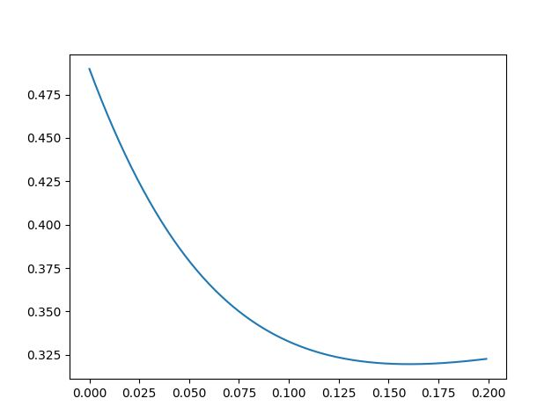

بر طبق تحلیل بالا می توان گفت که کمترین شباهت زاویه ای :

0.3196650688490703

که برای این مقدا ر*ای* بدست آمده برابر با:

0.162